LEVEL 4 FLOOR (1)
Handstand (for walkover, handspring and flic flac) | 1. Handstand with nose against wall – looking at hands – covering ears, hips open, bottom squeezed. Push “tall” up the wall – 1 min | 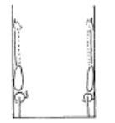 | - arms straight  - chest rounded, extended through the shoulders  - hips open  - gluteal muscles squeezed  - head neutral  - maintain good body tension and alignment  - toes or heels touch the wall only
 | 2. Handstand against horse | 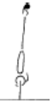 | - arms straight  - chest rounded, extended through the shoulders  - hips open  - gluteal muscles squeezed  - head neutral  - maintain good body tension and alignment
 | 3. Handstand on parrallettes
 | 4. Split handstand against box/wall
 | 5. F2-1.9 Handstand 360’ or more
Handstand Fwd Roll | Handstand “pop” fwd roll
 | F3-2.5 Handstand ½ turn fwd roll – turning the “inside” hand first – then the outside hand | 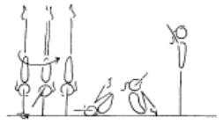 | - maintain good body tension and alignment  - place body weight onto right hand, maintaining  - the centre of gravity over the base of support  - turn the whole body as one unit  - head neutral  - extend through the shoulders prior to rolling  - encourage a straight body during the early phase of the fall  - roll in a tight tuck and stand to finish
Cartwheel / Roundoff | 1. ® © Cartwheel, cartwheel | 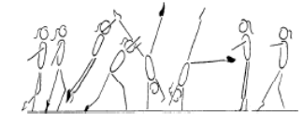 | - start with square hips and shoulders in the direction of travel  - lunge into the cartwheel maintaining square posture  - kick to a vertical side handstand with a small straddle  - first hand is placed same as a side cartwheel and becomes the support and rotational hand  - second hand is turned a 1/4 turn and placed pointing towards the first hand and becomes the repulsion hand  - head neutral  - body rotates 1/4 turn so that shoulders and hips are now square and facing the direction of travel  - head is neutral and eyes can see where the foot is about to land  - keep arms straight and chest in  - once the body is vertical over the second hand the chest lifts and the feet come down causing a ‘see-saw’ illusion  - the shoulders must not go past the vertical line  - finish in a stand with arms forward low horizontal  - chest in, hips open
 | 2. F4-2.5 Perform a roundoff from a rebound surface to a lower landing surface – to back | 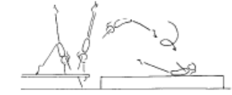 | - ensure the body remains within the vertical plain, no pike or arch action  - maintain good body tension and alignment  - repulsion from hands occurs during the vertical phase when the body is travelling upwards with the heel drive  - land in a dish shape with arms forward low horizontal
 | 3. ® © Roundoff rebound | 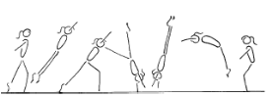 | - start with square hips and shoulders in the direction of travel  - lunge into the round off maintaining square posture  - kick to a vertical position  - first hand is placed same as a side cartwheel and becomes the support and rotational hand  - second hand is turned a 1/4 turn and placed pointing towards the first hand and becomes the repulsion hand  - gymnast must be in line with the first hand  - head neutral  - body rotates 1/4 turn so that shoulders and hips are now square and facing the direction of travel  - head is neutral and eyes can see where the feet are about to land  - keep arms straight and chest in  - once the body is vertical over the second hand the chest lifts and the feet come down causing a ‘see-saw’ illusion  - the shoulders must not go past the vertical line  - finish in a rebound with arms forward low horizontal  - chest in, hips open
LEVEL 4 FLOOR (2)
Backward Roll (for back salto) | 1. F2-4.5 Back extension roll down an incline to handstand with straight arms (then on the floor) | 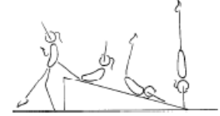 | - maintain body tension and alignment  - head neutral
 | 2. F2-4.6 Back extension roll to front support on raised surface, gradually build the height | 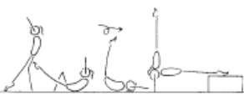 | - maintain body tension and alignment  - head neutral
 | 3. ®* Backward extension roll to handstand | 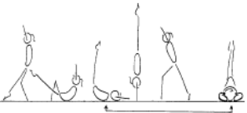 | - start position can vary  - smooth rotation and rhythm  - head starts neutral  - as roll commences the chin tucks onto the chest, then returns to neutral after the roll  - hands are placed on the floor early by hips then when weight has passed over the hands they move immediately to beside the head  - at the same time as the arms push the hips should extend quickly to assist the rotation  - finish position can vary
Stride Leaps | 1. Kicks fwds & bwds
 | 2. Kick holds fwds & bwds
 | 3. Kicks x 10, hold x 10, pulse at top x 10 – fwd & bwd
 | 4. ® © 2 x 180’ split leaps |  | - Chest vertical on take off, jump and landing  - 180 degree split shown in leaps
Turns | 1. ® © Straight jump with full turn |  | - Stretched position  - Good height
 | 2. ® © 360’ pivot on 1 foot |  | - Good passé position  - Straight supporting leg  - Turns on relevé  - Straight posture  - Turn entire body as one
FWO, BWO & Tic Toc | 1. Limber from stand – down to bridge and up again
 | 2. F2-5.7 Bridge from standing kickover to stand (back limber) | 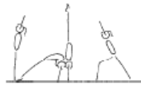 | - keep hips in line with feet  - stretch up first then open shoulders to initiate the bridge  - keep gluteal muscles tight  - maintain good body tension and alignment  - legs straight in the kick over (legs can be together - advanced, or in split)
 | 3. F2-5.8 Kick to handstand into a bridge, stand (front limber) | 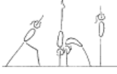 | - keep hips in line with hands during the handstand  - support phase  - stretch up first then open shoulders to initiate the bridge  - keep gluteal muscles tight  maintain good body tension and alignment  head neutral  use the muscles in the legs and hips to stand
 | 4. ® © Fwd or bwd walkover or  Tic Toc or  Backward roll to front support | 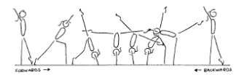  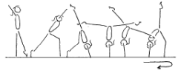 | - arms beside ears during all phases of the skill, with eyes looking at hands  - front walkover and tic-toc must pass through a vertical handstand prior to opening the shoulder angle to  - allow the bridge to occur (back walkover must start in a vertical stand before going back into the bridge phase)  - 180’ split of legs during the skill  - keep back and/or front legs still during scale phase  - arms straight, thumbs parallel and together  - the bridge action uses the hip and shoulder flexibility  - maintain good body tension and alignment  - square hips and shoulders throughout the skill

LEVEL 4 FLOOR (3)
Handspring | 1. From a standing hurdle off beatboard, perform a front handspring to 2 feet – to a soft landing mat
 | 1. F4-4.3 perform a front handspring from a run hurdle using a rebound or raised surface (bench), to a soft landing mat | 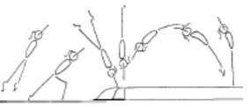 | - maintain good body tension and alignment  - repulsion from hands occurs when the body is travelling upwards with the heel drive  - land in an arch shape with arms by ears  - head neutral with eyes looking at hands
 | 2. F4-4.4 Same as F4-4.3 with a shape in front of the bench to force the gymnast to go up | 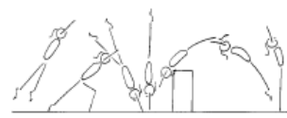 | - maintain good body tension and alignment  - repulsion from hands occurs when the body is travelling upwards with the heel drive  - land in an arch shape with arms by ears  - head neutral with eyes looking at hands
 | 3. ®*Handspring to 2 feet | 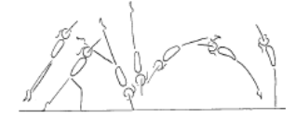 | - powerful heel drive - backward body snap  - lean forward into skill  - backward body snap to slightly arched handstand  - repulsion occurs as the body is still travelling upward prior to vertical  - forward body snap to dish shape during repulsion from hands  - land in slightly arched position, head neutral hips under  - immediate rebound with straight body
Flic Flac | 1. F4-3.5 Flic Flac on a padded box, hands land on the box, feet land on the supersoft mat | 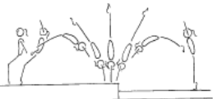 | - maintain body tension and alignment  - head neutral  - hands slightly turned in on contact  - emphasis initial starting and finishing position
 | 2. F4-3.6 Flic flac down inclined soft mat | 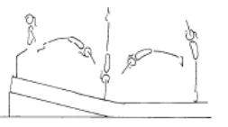 | - maintain body tension and alignment  - head neutral  - hands slightly turned in on contact  - emphasise initial starting and finishing position
 | 3. F4-3.7 Flic flac on a trampoline | 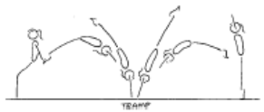 | - maintain body tension and alignment  - head neutral  - hands slightly turned in on contact  - efficient forward and backward body snap action
 | 4. F4-3.8 Flic Flac off a mini tramp or double mini tramp | 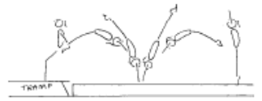 | - maintain body tension and alignment  - head neutral  - hands slightly turned in on contact  - efficient forward and backward body snap action
 | 5. F4-3.9 Flic Flac onto a raised surface – to overload the jump (land on feet or stomach) | 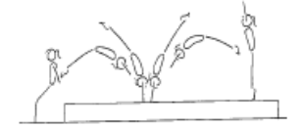 | - maintain body tension and alignment  - head neutral  - hands slightly turned in on contact  - efficient forward and backward body snap action
 | 6. F4-3.10 From handstand on a box, snap down onto a mini tramp, immediate flic flac | 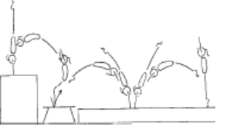 | - maintain body tension and alignment  - head neutral  - hands slightly turned in on contact  - efficient forward and backward body snap action
 | 7. ®* Roundoff Flick | 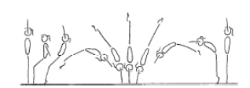 | - from initial starting position, the body starts moving backwards and body makes a smooth dish shape - chest in  - jump  - sequentially open hips, then open shoulders and arms in line with body (backward body snap)  - head neutral with eyes looking at hands  - land on hands in a smooth arch shape (open hips)  - rebound from hands to feet, forward body snap and strong push through hands, arms and shoulders  - a smooth landing with control and return to initial starting position

LEVEL 4 FLOOR (4)
Back Salto | 1. F6-1.7 Step from raised surface to mini tramp, 2 feet jump fwds with a ¼ counter rotation bwds to land on flat back in straight position on raised crash mats | 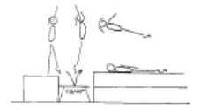 | - hips open  - shoulders open  - head straight between arms  - hips rotated under  - push hips forward  - arms close to thighs after feet leave mini-tramp
 | 2. F6-1.8 Snap down ¼ layout salto to back/shoulders | 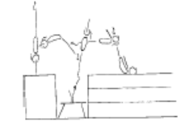 | - chest in  - hips open  - head neutral  - arms close towards body after feet leave the minitramp  - maintain body tension and alignment
 | 3. F6-1.9 ¾ Layout to stomach | 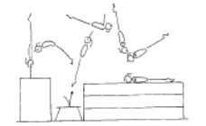 | - arms by side
 | 4. F6-1.10 Snap down straight body back salto | 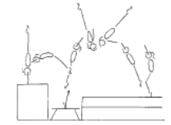 | - maintain good body tension and alignment  - fast rotation  - good height
 | 5. F6-1.11 Perform a roundoff flic flac rebound onto a raised surface | 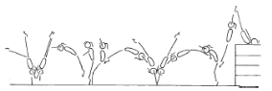

LEVEL 4 BARS (1)
Tuck Swings /Glides | ® © 2 Continuous glide swings (straddle glide – no deduction) | 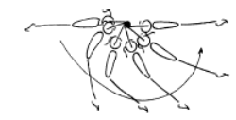 | - smooth rhythm  - good amplitude at the back and front of the swing  - maintain good body tension and alignment
Front Support /Casts | 1. ® © Cast to horizontal (min 45’ below horizontal) | 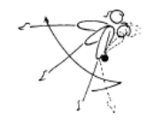 | - straight arms throughout the cast  - bring feet in front of the bar to initiate cast  - tip shoulders forward slightly  - cast feet backward and upward with a strong backward body snap  - straight body position at the ascent peak of the cast  - head neutral  - maintain good body tension and alignment bring all phases of the cast  - return to the bar
Back Hip circle | 1. ® © Backward hip circle | 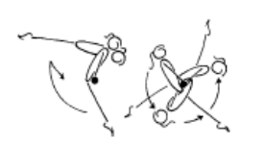 | - maintain good body tension and alignment  - arms straight  - head neutral  - after the cast the shoulders move backward whilst the feet move down, forward then upward  - push chest back  - rotation should be even and smooth  - wrists move quickly on completion of the circle  - finish in front support
Toe Shoot Dismount | 1. Cast to squat and jump off (aim is to get shoulders over bar)
 | 2. B3-2.6 From front support perform a piked toe shoot to stacked mats land on flatback, can also be done to land on feet | 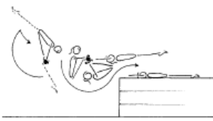 | - ensure good closure  - balls of the toes on the bar  - fast opening action off the bar  - good flight before landing on the mats
 | 3. ® © Toe shoot underswing | 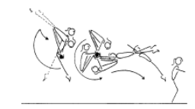 | - during the cast the body extends  - at the peak of the cast the feet move toward the bar as close to the hands as possible  - the path of the feet should be down and almost under the bar  - place the feet on the bar as late as possible  - the hips are far away from the bar as possible  - a tight closure should be visible, chest on legs  - powerful swing around the bar and extend body for flight off
Cast to Squat | 1. ® © Cast to squat | 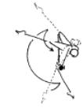 | - smooth movement  - easy rhythm  - shoulders forward  - high cast  - balls of the feet on the bar
Long Swings & Long Swing Pullover | 1. 3 x Tap swings on High bar (from kick start) | 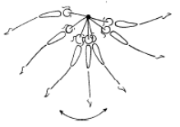 | - smooth rhythm  - swing should gain amplitude  - strong forward tap  - strong backward tap
 | 2. B4-5.1 Chin up pullovers x 10 | 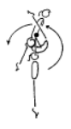 | - hips under, head neutral  - maintain good body tension and alignment
 | 3. ® © 2 x long swings to long hang pullover on the 3rd swing | 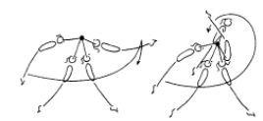 | - feet level with, or above, the low bar at the back of the swing  - chest in hips under, head neutral  - as the feet pass the low bar drive the heels back behind the bar and extend the hips  - pass through the vertical line in a slight arch shape  - powerful tap (forward body snap) to generate swing  - at the peak of the first forward swing the feet start to descend backward body snap will set up a powerful  - return swing  - repeat forward swing extend tap to circle body around the high bar  - finish in good front support

LEVEL 4 BARS (2)
Kips | 1. B3-6.1 with two feet in a sling, swing kip to front support x 10
 | 2. 20 x Bum ups – on the ground
 | 3. Straddle leg lifts – hanging on a high bar. Show star, rotate hips under through straddle position and up to touch bar x 10
 | 4. Glide – snap toes to the bar & hold toes to the bar
 | 5. B4-3.4 – Drop kip (may be assisted) – used to develop strength in kip action and to improve the ‘rhythm’ of the skill | 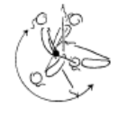 | - commence in a strong front support shape  - maintain shape during swing down  - keep arms locked  - bring the feet to the bar as the shoulders swing  - around the bar  - relaxed shoulders  - efficient kip action (hip extension)  - head neutral  - strong shoulder flexion then occurs  - move the wrists on top of the bar
 | 6. B4-3.4 Spotted glide kip, drop kip series x 5
 | 7. ®* Glide Kip | 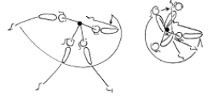 | - smooth rhythm  - good amplitude at the back and front of the swing  - maintain good body tension and alignment  - bring both feet to the bar early and fast, during the ascent phase of the forward swing  - kip action - shoot toes upwards fast  - arms straight throughout the skill  - fast wrist action  - closed front support position on completion
Cast to Handstand | 1. B4-4.1 Kick to handstand on a floor bar with assistance if necessary – begin with one foot on the bar
 | 2. B4-4.2 Front support flexion/extension activity with coach | 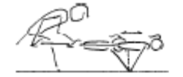 | - strong shoulder action  - chest in  - maintain body tension and alignment  - head neutral
 | 3. B4-4.3 Bounce to handstand using tyre | 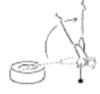 | - strong shoulder flexion  - shoulders forward of bar  - strong chest position  - awareness - demonstration of shoulder depression and extension; “push tall!”  - maintain body tension and alignment
 | 4. B4-4.5 From standing on a floor bar, jump straddle up to handstand | 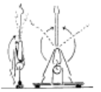 | - arms straight  - shoulders lean slightly over the bar at the start  - finish handstand with wrists, shoulders and hips in a vertical line  - legs straight and toes pointed  - straddle legs around the side
 | 5. B4-4.4 Cast to handstand – coach assisted, return to the bar in control | 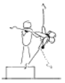 | - chest in  - shoulders forward  - fast heel drive and hip extension
 | 6. B4-4.7 From front support, cast to straddle with feet on 2 boxes, jump to straddle handstand

LEVEL 4 BEAM (1)
Front support Mount | 1. ® © Optional Mount (A not required)
 | 2. ®* Any B value mount
Releve/Turns | 1. ® © Lift leg to side passé, 180’ pivot on one foot to fwd passé x 2 on same foot, then releve hold for 2 sec on two feet at end |  | - Show passé positions  - Turn in relevé  - Straight posture  - Turn entire body as one
 | 2. ®* 360’ turn on 1 foot | 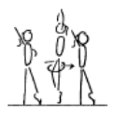 | - ensure correct posture at all times  - check toe point and position  - head up, eyes down  - keep shoulders and hips square  - keep body vertical  - do not lean forward or backward
Jumps /Leaps | 1. ® © Straight jump, split jump series (or vice versa)
Stride Leap | 1. 2 x fwd kicks then 2 x bwd kicks – R/L (min horizontal)
 | 2. ® © Stride Leap | 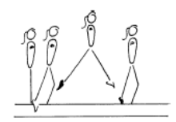 | - square hips and shoulders throughout the skill  - extended toes, ankles and knees  - legs should be level  - head up, eyes down  - arms out to the side
Handstand | 1. ® © Fwd entry handstand step in |  | - Show control  - Straight arms  - Straight legs  - Chest in  - Shoulders open
BWO, FWO &  Tic Toc | 1. M4-3.7 BWO on a high beam with a mat | 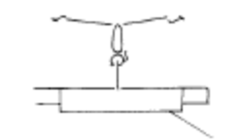 | - arms beside ears during all phases of the skill  - front walkover and tic-toc must pass through a vertical handstand prior to opening the shoulder angle to allow the bridge to occur (back walkover must start in a vertical stand before going back into the bridge phase)  - 180’ split of legs during the skill  - keep back and/or front legs still during scale phase  - arms straight, thumbs parallel and together  - the bridge action uses the hip and shoulder flexibility  - maintain good body tension and alignment  - square hips and shoulders throughout the skill
 | 2. M4-3.8 BWO on a high beam landing the skill onto a wide surface the same height | 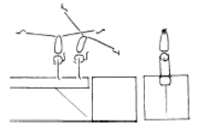 | - arms beside ears during all phases of the skill  - front walkover and tic-toc must pass through a vertical handstand prior to opening the shoulder angle to allow the bridge to occur (back walkover must start in a vertical stand before going back into the bridge phase)  - 180’ split of legs during the skill  - keep back and/or front legs still during scale phase  - arms straight, thumbs parallel and together  - the bridge action uses the hip and shoulder flexibility  - maintain good body tension and alignment  - square hips and shoulders throughout the skill
 | 3. ®* Backward walkover | 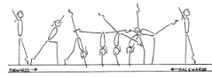 | - arms beside ears during all phases of the skill  - front walkover and tic-toc must pass through a vertical handstand prior to opening the shoulder angle to allow the bridge to occur (back walkover must start in a vertical stand before going back into the bridge phase)  - 180’ split of legs during the skill  - keep back and/or front legs still during scale phase  - arms straight, thumbs parallel and together  - the bridge action uses the hip and shoulder flexibility  - maintain good body tension and alignment  - square hips and shoulders throughout the skill

LEVEL 4 BEAM (2)
Cartwheel | 1. M4-4.5 Cartwheel on a high beam with a light mat, then without
 | 2. ®* Cartwheel | 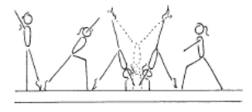 | - start with square hips and shoulders in the direction of travel  - lunge into the cartwheel maintaining square posture  - kick to a vertical position  - first hand is placed same as a cartwheel to handstand  - second hand is turned a 1/4 turn and placed pointing towards the first hand  - head neutral  - body rotates 1/4 turn so that shoulders and hips are now square and facing the direction of travel  - head is neutral and eyes can see where the feet are about to land  - keep arms straight and chest in  - once the body is vertical over the second hand the chest lifts and the feet come down causing a ‘see-saw’ illusion  - the shoulders must not go past the vertical line  - finish in a lunge with arms forward low horizontal  - chest in, hips open  - straight arms throughout the skill
Punch Set D/Mt | 1. ® © 2-3 running steps punch jump dismount |  | - Stretched position  - Two feet take off  - Good amplitude in jump, feet higher than beam  - Controlled landing

LEVEL 4 VAULT (1)
Bounce /Spring | 1. Ankle raises x 20 with both feet then 15 on each leg
 | 2. V1-5 Springing Circuit – variety of 8 objects
 | 3. Skipping rope x 100
Hurdles | 1. Hurdles on board – correct arms
Handstand Pop | 1. V3-4.4 Handstand ‘pop’ onto a raised surface | 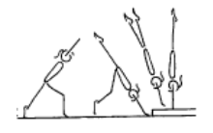 | - underarm action  - maintain good body tension and alignment  - hands contact floor early as heel are driving  - upward  - fast repulsion on the upward phase
 | 2. V3-4.2 Step from a low box to a board bounce up to handstand ‘pop’ on a box | 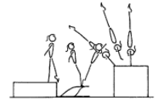 | - chest rounded  - maintain good body tension and alignment
Catsprings -Handspring Vault | 1. “Blocks” onto 105cm table
 | 2. ® © Handspring to flatback – mats same height as table | 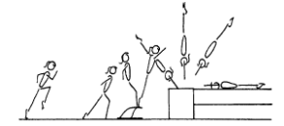 | - fast run  - low hurdle  - underarm action  - repulsion is instantaneous  - dynamic  - fast heel drive (backward body snap)  - hands contact vault early during the upward phase  - maximise air time in after flight  - good body tension throughout - legs straight and together, arms straight, head neutral
 | 3. V3-4.5 Long run handspring ‘pop’ onto a raised surface (3-4 supersoft mats) | 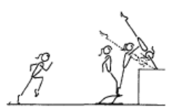 | - low hurdle - to capitalise on speed generated in the run  - contact the board slightly leaning backwards with only minimal flexion of hips and knees  - circle arms down the sides to thrust vigorously  - forward and upwards so that hands contact the horse as early as possible during the ascent phase
 | 4. Handspring over 90cm box | 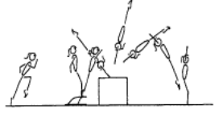 | - fast run  - low hurdle  - underarm action  - fast heel drive (backward body snap)  - hands contact box early during the ascent phase  - repulsion is instantaneous  - maximise air time in after flight  - maintain good body tension and alignment  - dynamic
Dive Roll / Front Salto | 1. Short run, hurdle with arm circle, tuck front salto to 60cm | 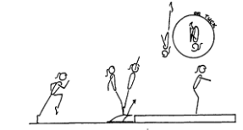 | - fast run  - low hurdle  - underarm action  - fast rotation  - maximum air time  - good body tension throughout  - dynamic  - shoulders travel vertical on take-off  - fast heel drive (backward body snap)  - on landing the hips, knees and ankles joints flex to absorb the landing
 | 2. V4-1.7 Jump from a box to a mini tramp or double mini, ¾ layout front salto onto 3 supersoft mats to land flat back | 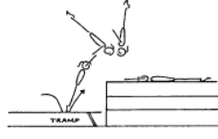 | - fast heel drive  - have slight arch throughout  - maintain good body tension and alignment

